Available on 192.168.1.101/mobility

1. In 3rd party application YouTube, when we click on authenticate link with you Tube and login with gmail id and click on Deny Access, then it shows link for back to <http://192.168.1.101/mobility/>. This link doesn’t work and give error.(Available on all browser)

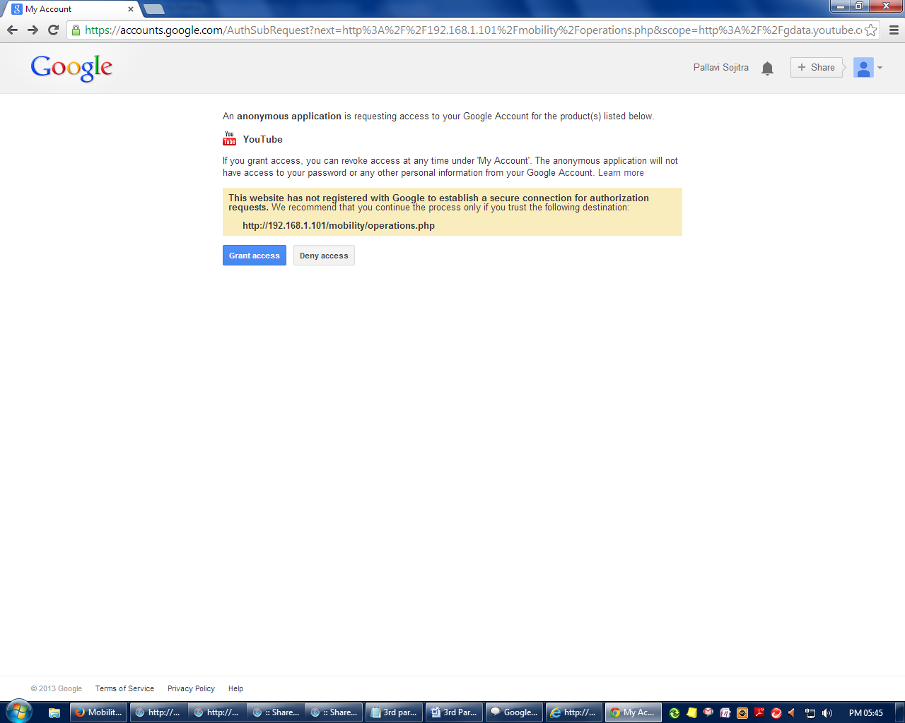

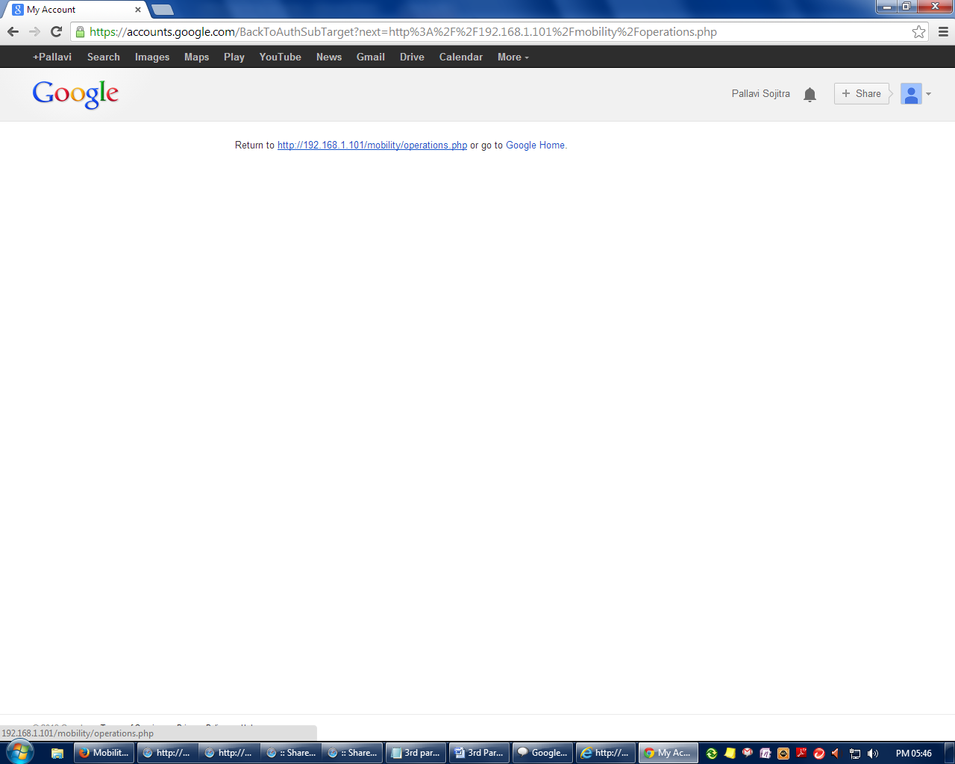

1. In 3rd party application Flickr, when we add user then it takes duplicate user name also (Available on All browser)

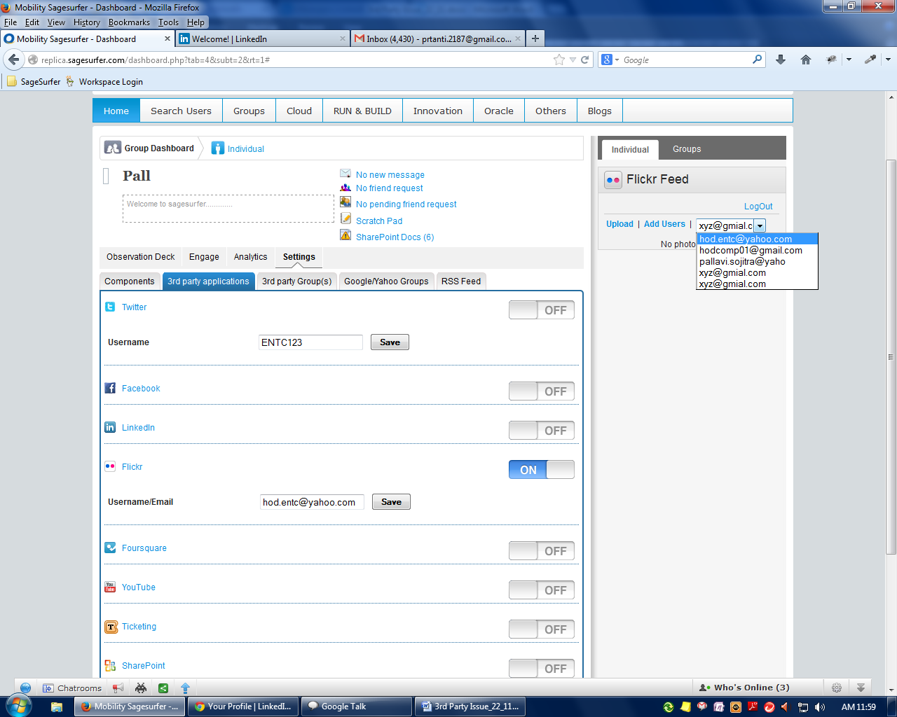

1. In 3rd party application SharePoint, , save button is not working (Available on Firefox) .

And after click on save, message is not displayed .(Available on Chrome)

